Project 1

Group 8: Jeevani Kondepati, Todd Heritage, Quiad Besing

Our group’s main hypothesis was testing the relationship between the price of electricity and the supply of wind power across the United States. We believed as the amount of wind power available increased, the price of electricity would go down. We broke the hypothesis into three questions to help us confirm or reject our hypothesis: 1) Does the production of renewable energy through wind turbines lower the price of consumer electricity? 2) Does the production of renewable energy through wind turbines lower the demand/price for coal? 3) Does the wind power capacity of states affect their price of electricity for that state?

**Question 1) Does the production of renewable energy through wind turbines lower the price of consumer electricity?**

As we look at the findings of the analysis we did to answer this question, we initially produced a figureof the cumulative amount of wind power in kilowatt hours over time, specifically 2001-2018 (figure 3). Unfortunately, in this figure we can see just from the figure, there is an obvious positive correlation between the two variables. However, when we adjust the price of electricity for inflation using the Consumer Price Index, we do see a different story (figure 4). In fact, indexing the price for inflation across the entire United States gives us a p-value less than 0.05 making it statistically significant. So, we conclude the increase in wind power does affect a lower price of electricity prices. 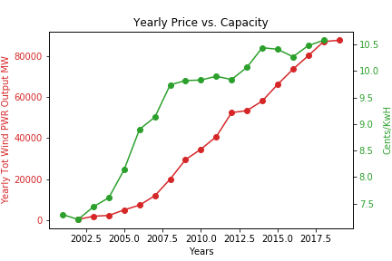

Figure 1

p-value: 9.125e-05

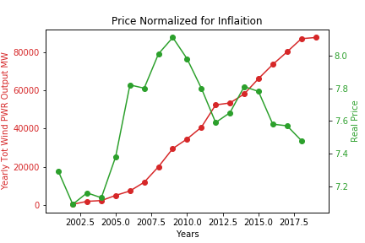

Figure 2

p-value: 1.133e-45

**Question 2) Does the production of renewable energy through wind turbines lower the demand/price for coal?**

Our findings for the second questions revealed there was a sharp decrease in the use of coal in the production of electricity. This is even more impressive because it holds true even though the overall power needs of a country with a growing population were likely increasing from 2001-2018. In figure 3 there is an obvious inverse relationship between the capacity of the power of wind turbines and the amount of coal burned each year. Our two sample t-test then produced a p-value well below the alpha of 0.05. Here, it appears we fail to reject our null hypothesis, leading us to conclude wind power is significantly correlated with the reduction in coal use when generating electricity. We also took a look at the overall generation of electricity by type of resource, this also produced a similar conclusion: coal use (and fossil fuels in general) have gone down while wind has increased.

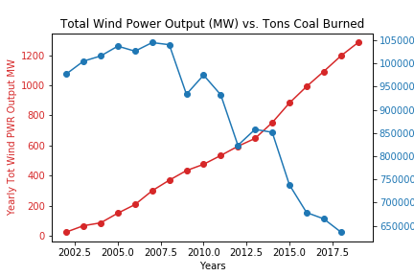

Figure 3

p-value: 1.690e-14

Figure 4 Figure 5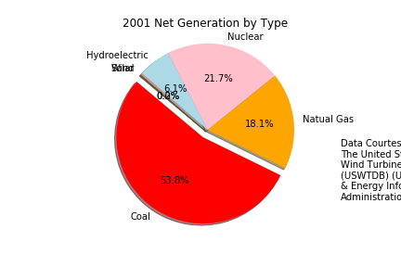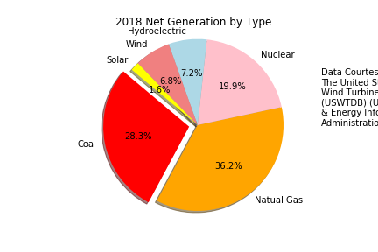

**Question 3) Does the wind power capacity of states affect their price of electricity for that state?**

The last question we asked produced the least promising results of our project. Upon analysis of the state level data of electricity prices and their capacity of electricity from wind turbines, we created a scatter plot of those two variables to attempt to find a negative correlation. However, if you look at figure 6, there is the appearance of a mild negative correlation but nothing that stands out. The trend line helps illuminate the possible correlation, but the p-value is slightly above the 0.05 alpha level we were testing against. In figure 7, we plotted the location of wind farms across the US as of 2018 and this reveals there are states, mainly in the southeast, with no wind turbines. As the number of wind turbines grew, this was a startling discovery for us that there were some states without wind power contributing to their electrical grid. 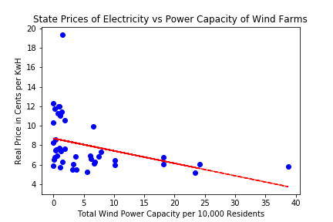

Figure 6

p-value: 0.0556

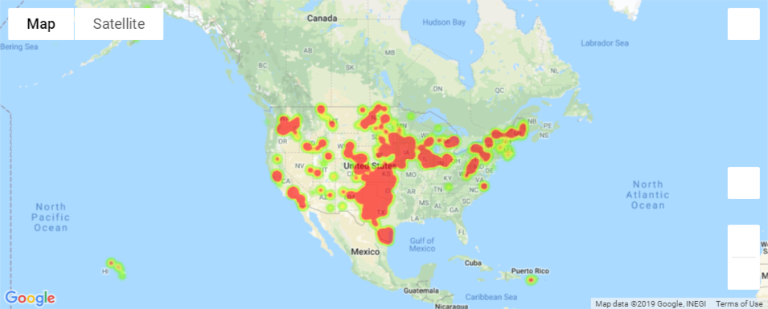

Figure 7